

Fetch KPI Update - January ‘25

One month into the new year, and we’ve got some exciting updates to share!

## Starting with our core Brand metrics, let’s take a look into our ongoing performance:

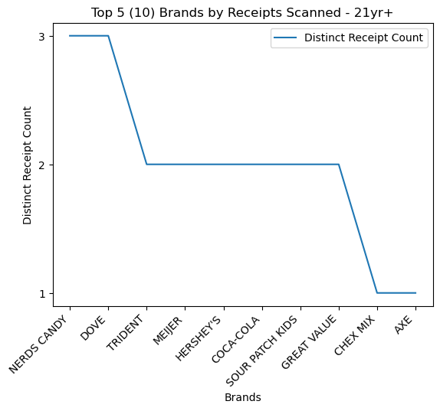

While we normally concentrate on Top 5 Brands based on receipt scans, we’ve instead shown our top 10 brands due to overlap for positions 3rd through 8th. Leading with 3 receipt scans, Nerds Candy and Dove still have some close competition in the rearview mirror.

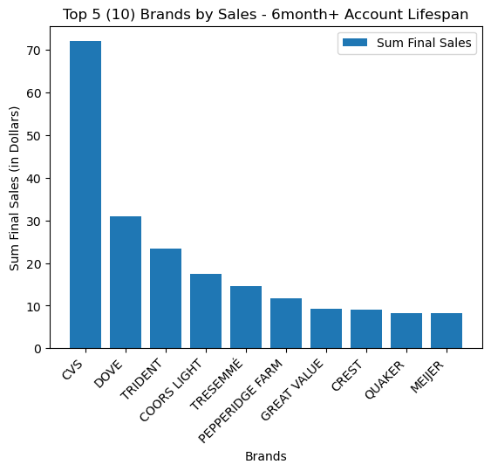

Comparatively, of our top 5 brands based on total sum of final sales, Dove and Trident are the only 2 brands showing in the top 5 of both charts. I’d be curious for deeper insights into their marketing and advertising tactics to identify opportunities we can introduce to help escalate our other trusted brands.

## Which leads us into a glimpse of our Fetch Power Users:

| User ID | Unique Receipt Count | Sum Final Sales | Account Duration |
| --- | --- | --- | --- |
| 6528a0a388a3a884364d94dc | 3 | $6.25 | 495 days |
| 610a8541ca1fab5b417b5d33 | 3 | $10.97 | 1295 days |
| 62c09104baa38d1a1f6c260e | 3 | $11.30 | 963 days |
| 62ffec490d9dbaff18c0a999 | 3 | $26.14 | 915 days |
| 5c366bf06d9819129dfa1118 | 3 | $12.20 | 2233 days |
| 61a58ac49c135b462ccddd1c | 3 | $14.99 | 1177 days |
| 5ca54049adfcb4140b54e1bf | 2 | $7.24 | 2149 days |
| 5c6c2998b06c0045a4fddc74 | 2 | $5.46 | 2192 days |
| 5b441360be53340f289b0795 | 2 | $10.33 | 2416 days |
| 5f6518d1bf3f5a43fdd0c9a5 | 2 | $11.22 | 1615 days |

(Power Users are defined as repeat customers via unique receipt count)

We have 6 Power Users tied for first place, with 3 unique receipt scans each, and $26.14 total spend leading the pack. We’ve included Account Duration per Power User to start the 2025 conversation of “How do we engage new account users to participate in the Fetch program similar to our longer tenured users?”

By continuing to focus on offering an excellent experience to our short and long tenured users, we can compete to meet our H1 2025 success projections!

## Now for the most important question:

We all know Wes Schroll lives and breathes his opinion that Pace is the far superior ‘Dips & Salsa’ brand, but we’ve got some data that says otherwise…

| Brand | Sum Total Quantity | Sum Total Sales |
| --- | --- | --- |
| TOSTITOS | 60 | $260.99 |
| PACE | 38 | $118.58 |
| (Brand not provided) | 35 | $154.37 |
| FRITOS | 33 | $91.73 |
| MARKETSIDE | 23 | $103.29 |

Pace is comfortably sitting in 2nd place, but we can’t help but notice (Brand not provided) and Fritos coming in a close 3rd and 4th position for total quantity. This (again) validating the opinion of the Data Analytics dept, that Tostitos will always be the better ‘Dips & Salsa’ brand!

In summation, we’re on track for a great 2025. Our customer experience betterment initiatives are set to drive us to and beyond our H1 ‘25 projections! Let’s go make a difference as we do every day, by offering our customers excellent perks and benefits and increasing brand awareness and success for our clients.

(As always, feel free to reach out with questions, or if you’d like to see how we quantified these results.)

- Best,

David and the Data Analytics dept